## Basic Information Availability

* Platform: Smartphone and PC, Websites
* Store: Steam, Apple App Store, Browser game websites.
* Price: £3.00 - $3.67
* PEGI Rating: 7+
* Developer: Dead Dark Studios
* Release Date: 5th May 2017
* Online Website: DarkDeadStudios.com
* Based in Southwark London England
* Available Languages: English, French

Spanish, German, Russian.

## *Social Media Contact Details*

* Personal Email: [Twssimmons@gmail.com](mailto:Twssimmons@gmail.com)
* Company Email: [DeadDarkStudios@gmail.com](mailto:DeadDarkStudios@gmail.com)
* Phone Number: 07415958549
* *Facebook*
* *Twitter*
* *Instagram*
* *Kickstarter*
* YouTube

## Description of the Game

Phantasm is a single player 64 bit 2d side-scroller puzzle game where a young man who has had a poor upbringing and has some of his experiences haunt him in his sleep. At the start of the game there is a small cut-scene where the player’s character is walking across a road, suddenly he gets run over by a speeding car and bangs his head on the tarmac causing him to go into a coma. The game screen then turns black with dramatic music. We did this so the players get hooked into the game and find out what happened to their character. After this happens the player is then brought to the start of the game.

Players then take control of their character and must battle environments based on his past and he must find a route out of the environment by earning a key from completing puzzles. Players must jump, dodge and direct their character to find the puzzles to complete to pass to the next level and escape from his coma.

In each level, there are clues he player can find or hear to help them guide themselves to the puzzles in each level and use coins collected to help them complete the puzzles on time.

## Main Features

Puzzles

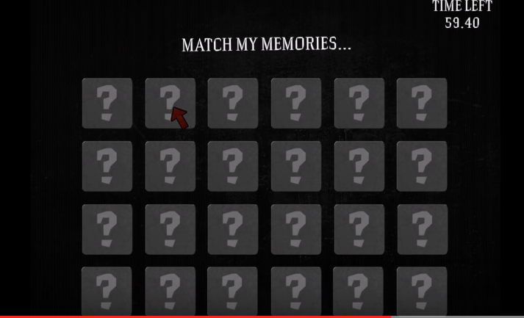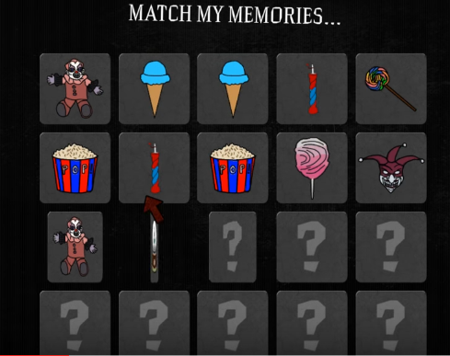One of our main features of our game is the puzzles. The puzzles as shown below are a blind tile game where the players must memorise and select the matching tiles before the time limit runs out. When the player first enters the puzzle the platforms are shown for a very brief period to add tension to the player’s memory.

Each tile in all the puzzles are related to the player’s character is stuck in and are either good or bad memories from the character’s experience from the theme. If the timer runs out before the player completes the puzzle they must try again. Also as the player progresses through each level they get harder to complete.

Collecting

Another main feature of our game is collecting. Whist players are lost in the level they can collect these white fuzzy balls and once the player has enough they can use it to help them guide themselves in the right direction in any level.

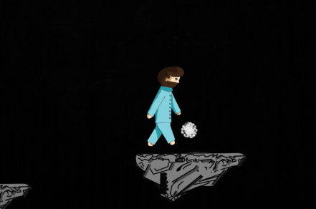

Jumping

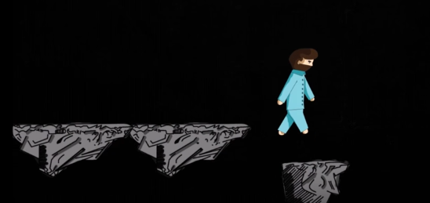Another main feature of our game is jumping. The players need to jump to reach the platforms on the map and progress through the level.

As shown above the player’s character has just jumped off the platform and is about to land on another. This gets progressively harder as the player progresses. This will include disappearing, elevated and moving platforms as shown below.

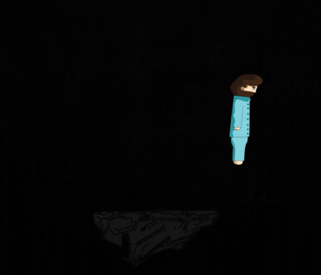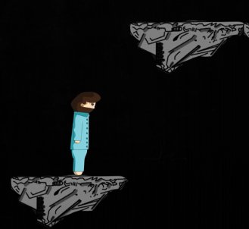

## History of Dark Dead Studios

Dead Dark Studios is an independent games developer, founded in September 2016 by four recently graduated students from University of Suffolk. We are a nice and cheerful bunch who have known each other for at least 3 years and are passionate about games. Our goal for our first game is to make an awesome puzzle game that has a lot more for the player to do other than completing puzzles and cause them to be fully immersed into the game world. Our team have worked on a lot of other games whist at university which include personal and group developed games and have learned what not to do and what to do whist making an game, which means we are truly determined to be noticed.

In the future, we plan to create games which are fun as well as challenging for the players. We all want to delight you with our passion and eagerness to learn. We want to make games that are for the family as well as friends but most of all give everyone, gamers or not a great experience. We are so excited to start developing games frequently which we love and you will love.

**Word count: 690**